COVERING LETTER

To,
The Respected officials,
Please accept the enclosed resume as an expression of interest in exploring employment opportunities with your organization. I am well respected in my profession as an upstanding, hardworking Individual who can be counted on to “get the job done
.Though my resume is detailed and comprehensive, it cannot fully demonstrate the manner in which I have achieved success. Character, personality, and the ability to work hard in a team environment can be evidenced in a personal meeting. I would welcome an interviewing opportunity at your earliest convenience. Thank you for your time and consideration. I am certain that I can be a contributing member of your company.
With regards,
Shreya Banerjee
Shreya.spidergo@gmail.com
Enclosure: Resume

RESUME

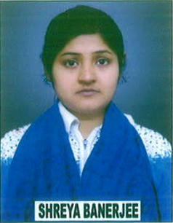

Name: Shreya Banerjee
Contact No. : +91-8738810461
Email: shreya.spidergo@gmail.com
Address: 1991/1144-A Baluaghat,
Dist.- Allahabad (U.P.) India

Academic Qualification:
Courses | Name of Institution/Board/University | Year of Passing | Percentage/CGPA
Diploma | Institute of Engineering and Rural Technology | 2014 | 69.9%
Intermediate | Aryan Kanya Inter College Allahbad (U.P.Board) | 2010 | 56.4%
High school | Aryan Kanya Inter College Alahabad (U.P. Board) | 2007 | 60.5%
Teaching Experience: Over 2 Years

Hobbies:
- Reading Books & Magazines.
Language known: English, Hindi & Bengali.

Personal Details:
Name : Shreya Banerjee
Father’s Name : Mr. S.P. Banerjee
Sex : Female
Marital Status : Single
Nationality : Indian
Permanent Address : 1991/1144-A Baluaghat,
Dist.- Allahabad (U.P.) India
Phone No : +91- 8738810461
Date of Birth : 08/10/1991
Declaration:
I hereby declare that the above-mentioned information is correct up to my best knowledge and I bear the responsibility for the correctness of the above-mentioned particulars.

Place: Allahabad (Sherya Banerjee)
Date:

